**Blood Bank System**

Project submitted to the

SRM University – AP, Andhra Pradesh

for the course project of

**CSE305L Software Engineering Lab**

Submitted by

**Kandula Lohith Ranganadha Reddy**

**(AP20110010161)**



**SRM University–AP**

**Neerukonda, Mangalagiri, Guntur**

**Andhra Pradesh – 522 240**

**[May 2023]**

# Table of Contents

**Table of Contents 1**

Abstract 2

1. Introduction 3

1.1 Purpose 3

1.2 Scope 3

**2. Literature Review 4**

2.1 A Study on Blood Bank Management 4

2.2 Designing a Web-Based Blood Bank Information Management System for the National Blood Bank of Ethiopia 4

2.3 Blood Bank Management system………………………………………………….4

2.4 Development of a Blood Bank Management System…………………………5

2.5 Blood Bank Management System Using Rule-Based Method………………5

**3. Discussion 6**

**4. System Requirements 7**

**5. Proposed Scheme 8**

**6. Results/Screenshots 11**

**7. Conclusion 2****2**

**8. Future Work 2****3**

**References 2****3**

# Abstract

The Blood Bank system is a project aimed to reduce the difficulties that this current manual record-keeping method has. The major goal is to make the user's experience as streamlined and effective as possible, allowing them to add various details like new donors, view by geography, blood supply, etc. The aim of this blood bank system is to maintain the efficiency, accuracy, and safety of blood donation and several other processes like transfusion. It also helps to maintain a record of blood donors, inventory, and history. This leads to better patient outcomes and reduced risks associated with blood transfusions. The program has been made as simple as possible to prevent mistakes while entering data, and it alerts us when we enter data that is incorrect, demonstrating how user-friendly the project is. It can assist the user to concentrate on their other activities rather to concentrate on record keeping. Thus, it will help the organization in better utilization of resources. We can find the menu option donor in this we can add donor details and update the details of the donor if needed and even we can view all the details of the donor added. In this way, we can efficiently use this project where we can find details in a systematic manner. And there is another menu called Search blood donor where we can find the donor details using the location which makes it easier. Finally, this project will aid any organization in making better use of its resources. Its primary goal is to support strategic planning and help you make sure your organization or bank has the necessary level of information and data to achieve your long-term objectives. In the end, these solutions will enable you to manage resources more effectively.

# 1. Introduction

## Purpose

The Blood Bank System is a project created to reduce the difficulties that this current manual record-keeping method has. The major goal is to enable the user to conduct operations in a simple and effective manner. a method through which the user can add numerous details, such as a donor, view by location, the blood supply, etc. The program has been made as simple as possible to prevent mistakes while entering data, and it alerts us when we enter data that is incorrect, demonstrating how user-friendly the project is.

### 1.2 Scope

This project is designed to assist in strategic planning, and will help you ensure that an organization/Bank is equipped with the right level of information and details for your future goals. These systems will ultimately allow you to better manage resources. The project is developed in such a way that it works for a blood bank to maintain its records and to add and delete donor information. This project will be made some changes later on and will be a site that will be used online. The blood drive management system is developed to make the job very much easier for the user it is user-friendly and no guidance is required for the user to work on it. Finally, this project will help any organization in better utilization of resources and the main scope is that this project is designed to assist in strategic planning and will help you ensure that the organization/Bank is equipped with the right level of information and details for your future goals. These systems will ultimately allow you to better manage resources.

# 2. Literature Review

## 2.1 A Study on Blood Bank Management

Blood Bank System was designed to manage donor records and blood bank operations. The system allowed authorized administrators to log in, access a central database, search for donors, and easily add or update donor information. The aim of the system was to streamline the blood bank process and it was intended to be adaptable for various types of blood banks. The authors mentioned the inclusion of user roles such as hospital administrators, doctors, and blood bank receptionists. However, the paragraph points out that important details are missing from the study, such as the research method employed, screenshots of system prototypes, and information about respondents, samples, and sampling techniques. The researchers also mentioned their intention to provide visual aids and discuss their research methods, sampling procedures, and statistical treatment in future work.

### 2.2 Designing a Web-Based Blood Bank Information Management System for the National Blood Bank of Ethiopia

Numerous studies have been conducted in the field of blood banks, focusing on different aspects. Some studies aim to manage donor records to facilitate the donation process, while others concentrate on connecting multiple blood banks into a single system with a shared database. Additionally, certain studies explore the use of modern technologies such as electronic cards and barcode systems. The Blood Bank Information Management System is an information system specifically designed to store, process, retrieve, and analyze administrative and inventory management data within a blood bank. This system enables authorized blood bank personnel to log in using a secure password and easily manage donor and patient records. It not only benefits professionals but also attracts donors and other stakeholders due to its user-friendly reservation system and timely notification of donation opportunities to those in need. Furthermore, the system allows stakeholders and regional blood banks to readily access information about the types and quantities of available blood at various blood bank centers.

**2.3 Blood Bank Management System**

The researchers developed a web-based blood management system to improve the management of blood donor records and the distribution of blood products across different regions. They identified that the manual-based system for entering donor details led to difficulties in tracking blood donation activities and resulted in erroneous information. They highlighted the drawbacks of a manual system, including time wastage, error-prone results, high manpower requirements, lack of data security, slow data retrieval, and time-consuming report generation. By implementing the web-based system, the researchers aimed to provide quick access to donor records and timely, confidential, and secure medical reports. The system had three user roles: Administrator, Donor, and Acceptor, each with a unique user ID and password. The application was developed using ASP.NET, C#.NET, and SQL Server for the database. However, the research paper did not mention the specific research methods used. The study highlighted the importance of web-based blood bank management systems for accurate and readily available information to enhance blood transfusion services, and it emphasized the impact of information technology on improving healthcare services. The researchers also recognized the suitability of programming languages like ASP.NET and PHP for web-based applications.

**2.4 Development of a Blood Bank Management System**

Three benchmark systems were selected for the development of the Blood Bank Management System (BBMS): Blood Bank India (BBI), Lions Blood Bank & Research Foundation (LBBRF), and a previous standalone version of BBMS. BBI is a website where Indian citizens can register as blood donors and request bloodstock. LBBRF is a private organization that collects fees from blood recipients to cover donor recruitment and education expenses, ensuring safe blood transfusion. LBBRF also publishes the current blood stock status on its website and informs the public about upcoming events. However, LBBRF lacks features such as donor monitoring and access to blood screening results. The previous standalone BBMS version used Microsoft Access as the database and included modules for user account management, stock list viewing, donor registration, and customer registration. A blood donation sample report was also included in the system.

**2.5 Blood Bank Management System Using Rule-Based Method**

The study emphasized the importance of using an information system in blood banks and highlighted the disadvantages of manual systems, such as duplicate data entry and the potential loss or missing of data over time. To address these issues, the author developed a web-based system that enabled fast and easy recording of donor details. The system utilized rule-based decisions and could send messages to donors when specific blood types were needed. The system was developed using an incremental model, which allowed for phased development, flexibility in making changes, and the ability to correct errors during testing. However, the study noted that the developed system lacked functions for checking the availability and expiration of blood bags and products. The researchers acknowledged this limitation and stated their intention to include these features in their own system to enhance the safety of blood transfusions.

# 3. Discussion

Blood bank systems play a critical role in ensuring the availability and efficient management of blood and its components for transfusions. These systems automate and streamline processes such as donor registration, blood testing, inventory management, and transfusion tracking. While blood bank systems have brought significant improvements to the field of transfusion medicine, there are still some disadvantages associated with the existing systems that need to be addressed.

**Disadvantages of the Existing System:**

● The existing blood bank system frequently depends on labor-intensive and error-prone human data entry.

● With manual systems, there is a higher risk of duplicate donor records.

● Manual systems often lack real-time updates, making it difficult to have an accurate and up-to-date inventory of available blood products.

● Lack of Integration with Modern Technologies

● Data Loss or Misplacement

● Inefficient Communication and Coordination

To overcome the disadvantages of the existing manual system, a software application named Blood Bank System which is available for all the users is proposed.

# 

# 4.System Requirements

**Software Requirements:**

● Apache Server 2.0

● PHP version 5.3 or above

● MySQL Version 5.5 or above

● Latest browser : Chrome, Firefox, Safari etc

● Operating System : Any(Linux, Windows,Mac etc)

**Hardware Requirements:**

● Core i5 processor

● 2GB Ram

● 20GB of hard disk space in terminal machines

● 500GB hard disk space in Server Machine

# 5. Proposed Scheme

The proposed scheme for the blood bank system aims to address the limitations of the current system and enhance the efficiency, accuracy, and safety of blood donation and transfusion processes. The key components of the proposed scheme include Donor Management, Inventory Management, User Management, and other functionalities.

* Real-time inventory management with expiration date tracking and stock replenishment alerts.
* As it is computerized, human errors can be avoided
* Web-based platform accessible from anywhere with internet connectivity.
* Robust data security measures to protect sensitive donor and patient information.
* Integration with other healthcare systems and electronic health records.
* Communication and notification features for donors, healthcare professionals, and blood bank personnel.

**System Architecture:**

The project Blood Bank system is created as a client-server application that uses a web browser. The following elements are part of this system.

**Client-side:** an intuitive web interface that users, employees, and administrators can utilize.

**Server-Side:** A strong server infrastructure to manage system operations and process data as well as answer user requests.

**Database**: A consolidated database for data on bloodstock, employee information, donor information, and other pertinent information.

**Functionalities**

**User Management**

● User registration

It allows users to register by filling in their personal information

A join us page is provided for new users to join the blood bank community

● User can check blood availability

It enables the user to check the blood availability for each blood group. And he can check the donor's medical information.

● User can contact, and see members in the blood bank

It enables the user to check our about us page and our member's page. user can also contact us if he has any queries

**Admin Management**

● Admin Login

It allows the admin to login to the system

● View staff details

The system administrator can access and examine the information about the donors/employees. With the help of this function, the administrator may manage and supervise the workforce effectively by having access to detailed information about the donors/employees.

● Add donor/employee information

The admin can add the new donor/employee information to the existing database by providing the necessary information about the particular employee.

● delete donor/employee information

The admin can delete the donor/employee information to the existing database.

● edit donor/employee information

The admin can edit the donor/employee information in the existing database.

**Donor Management**

● Donor Login

Specific username and password will be given by the admin to the donor. With those credentials, the donor can log in to the system.

● Add new donor

The donor can add new donors by giving the personal information and medical information of the new donor.

● Search for donors

The donor can search for blood by searching for the blood group or by searching with the city name.

# 

# 

# 

# 

# 

# 6. Results/Screenshots

**Home page:**



**About us:**

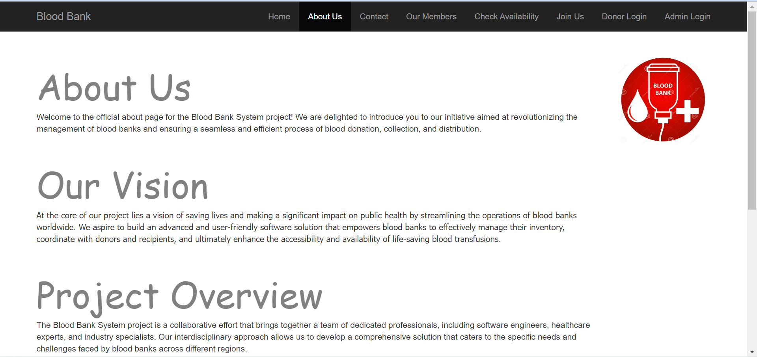

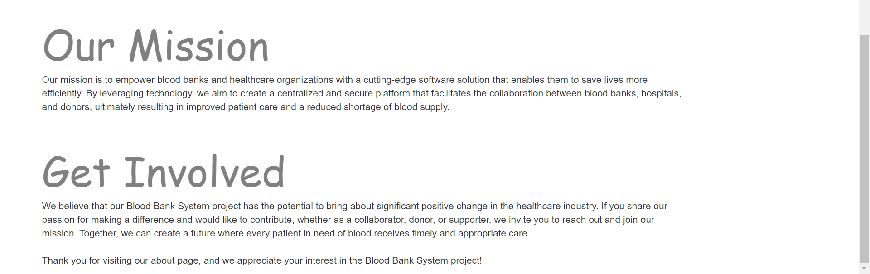

**Contact:**

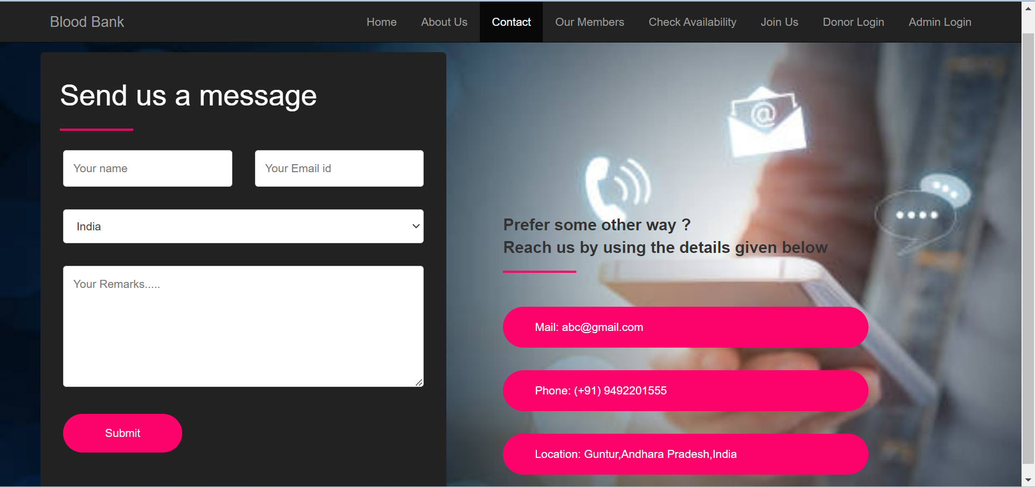

**Our Members:**

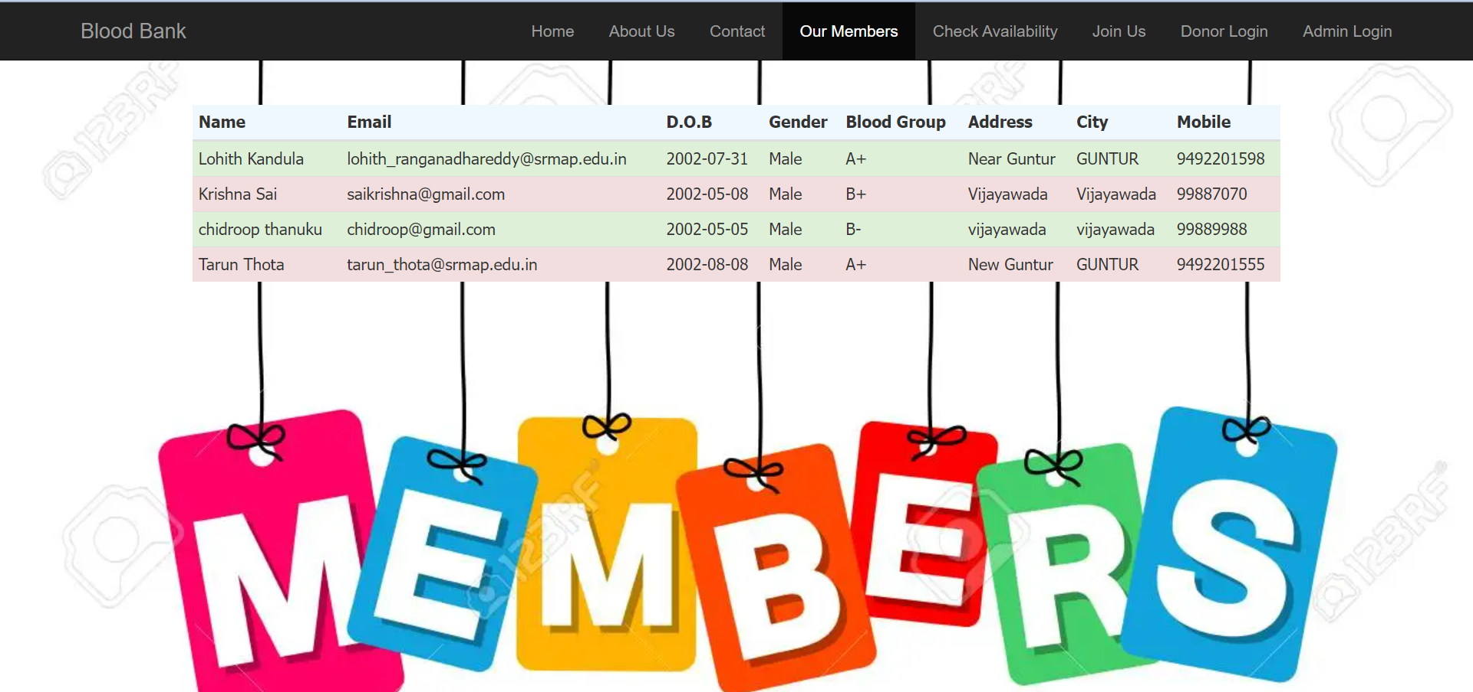

**check Availability:**

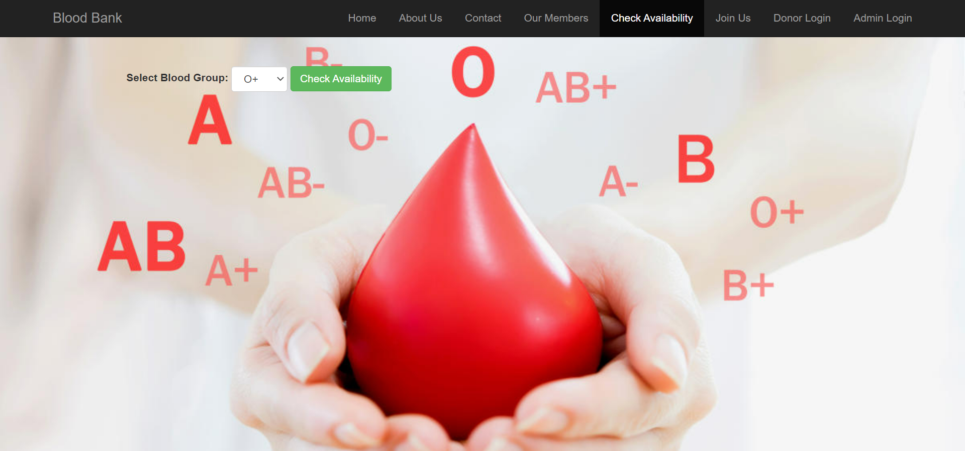

**After searching for the blood group:**

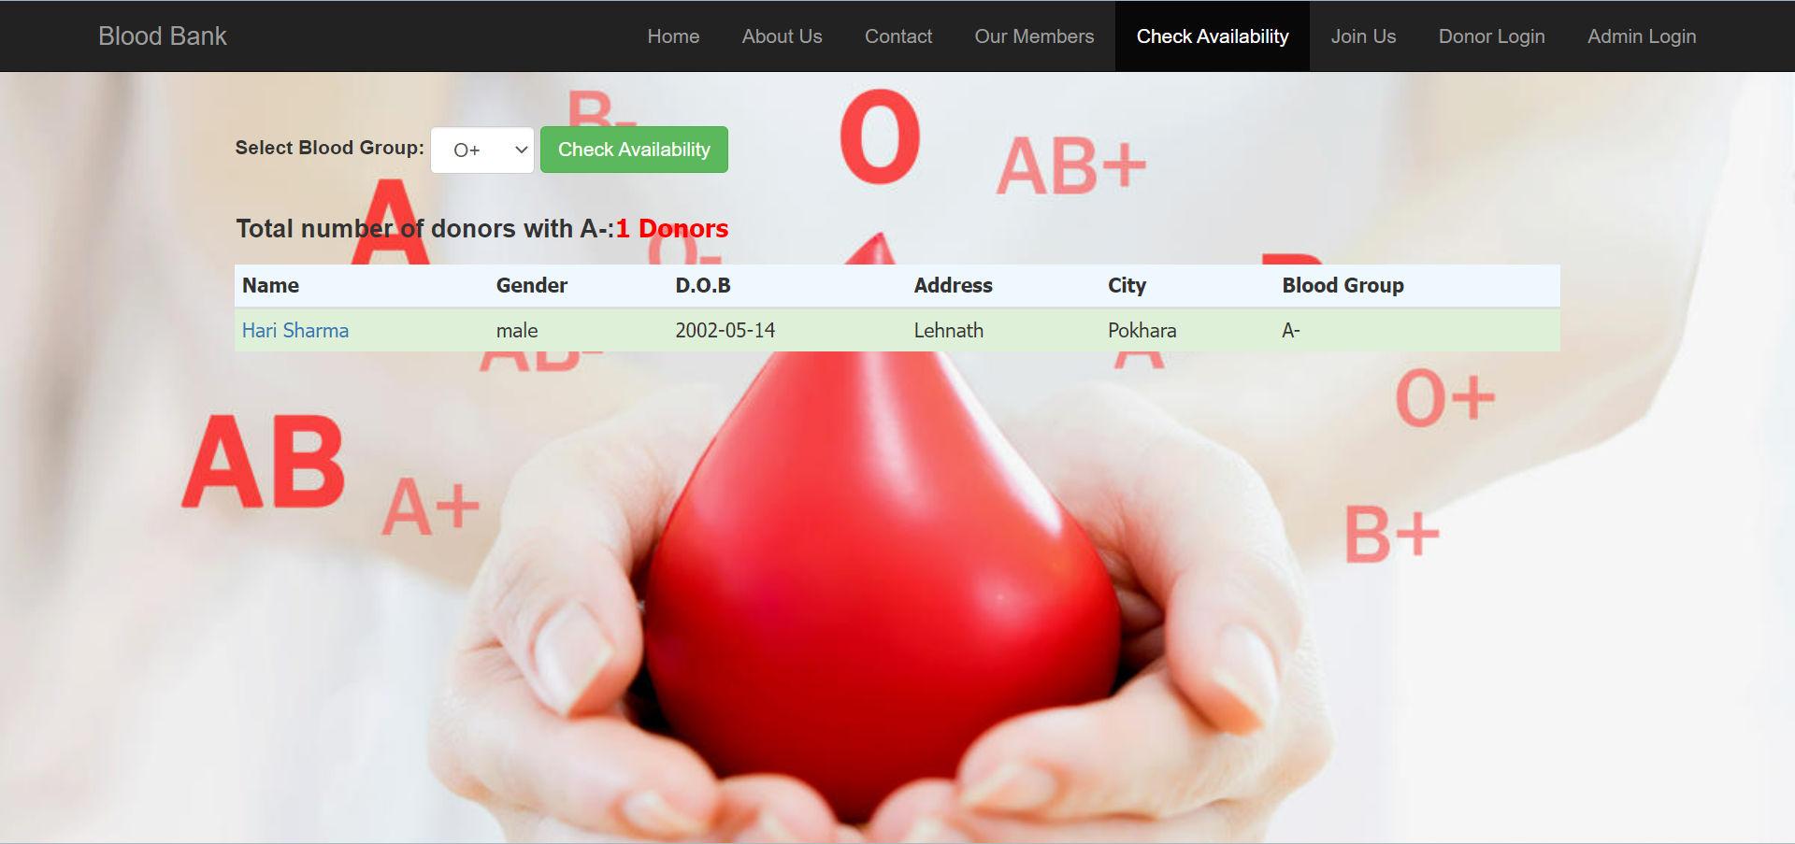

**After clicking on the donor name:**

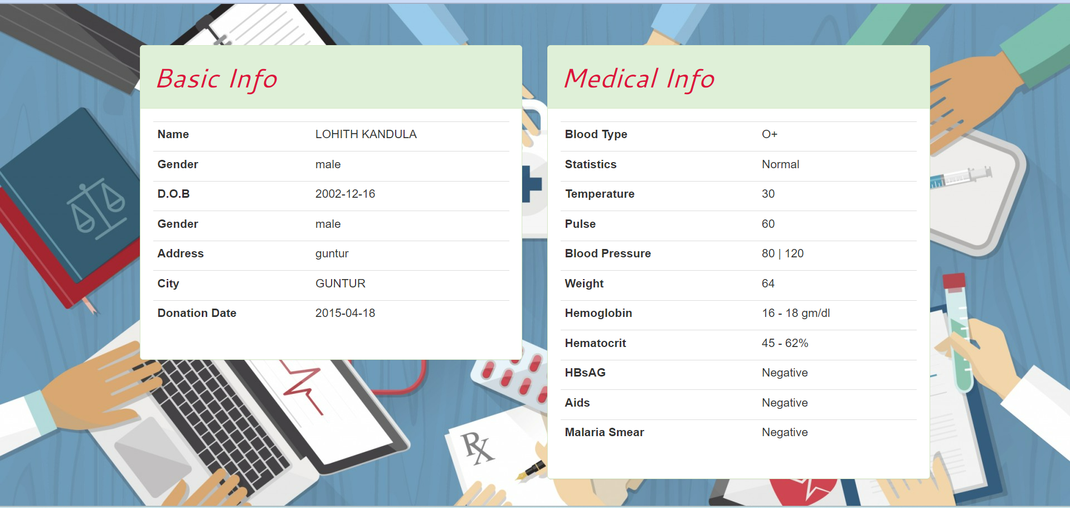

**Join us:**

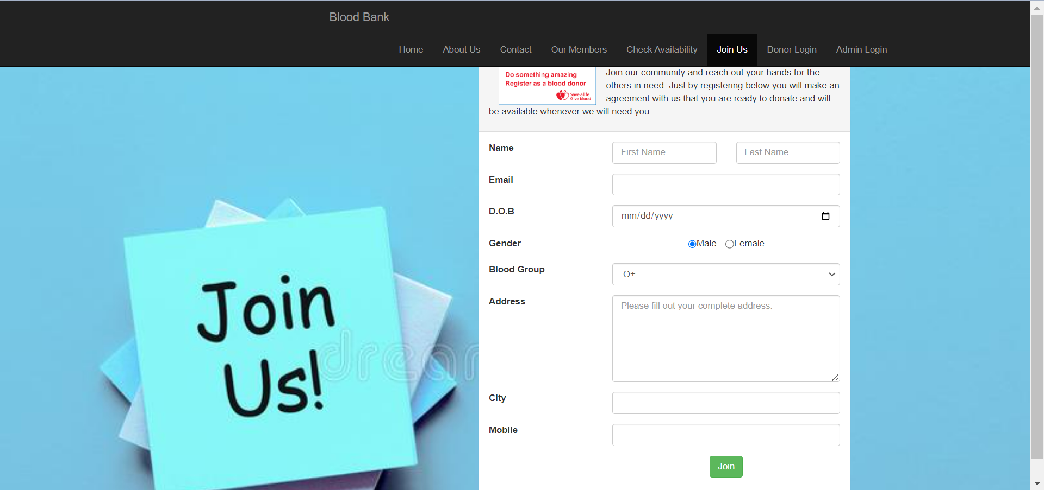

**Donor Login:**

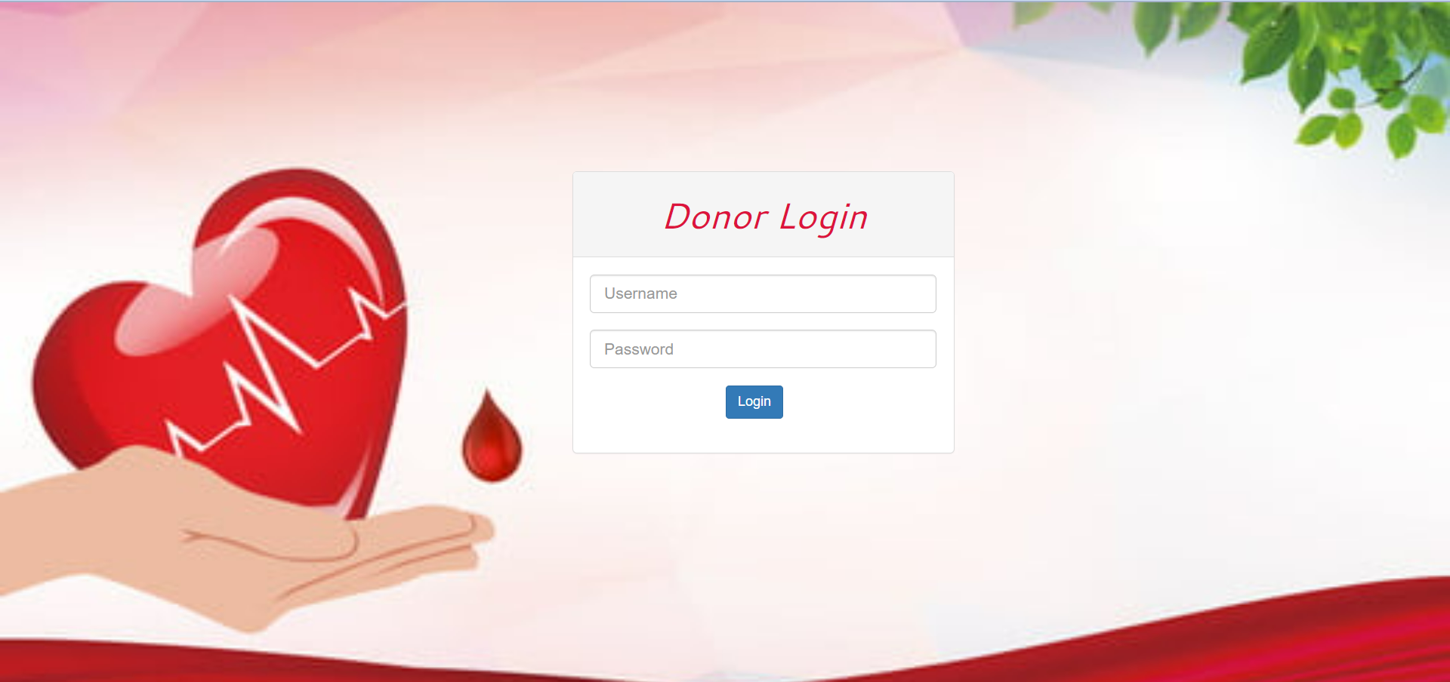

**Donor after Login:**

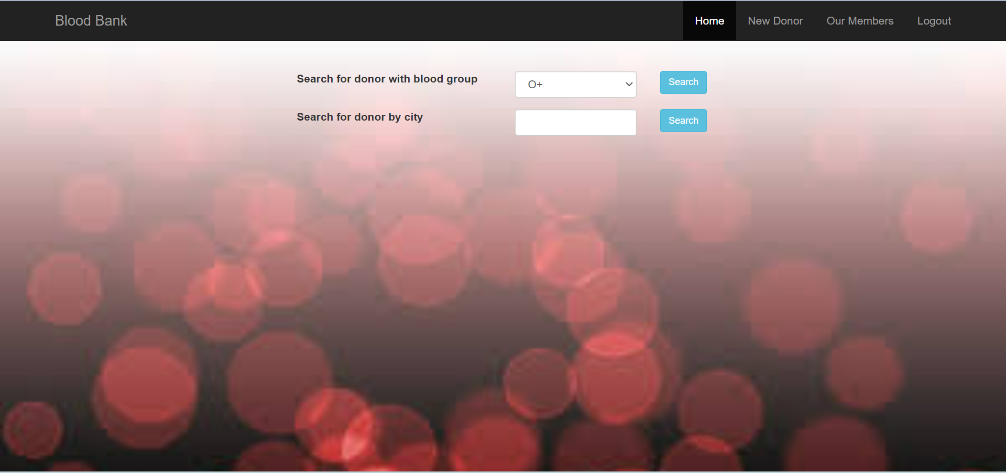

**Search for the donor with blood group:**

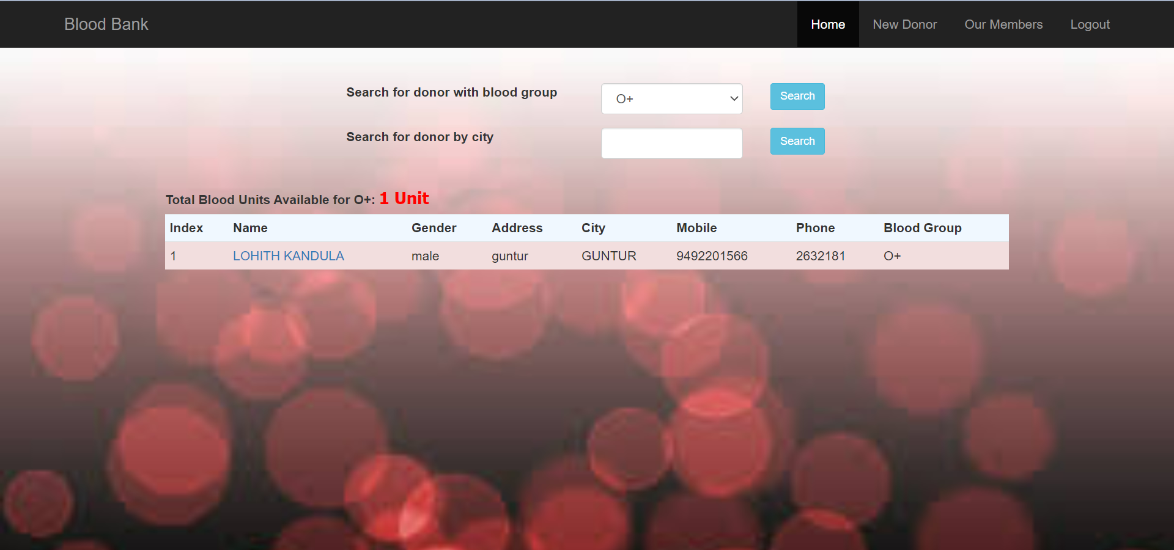

**Search for the donor with the city:**

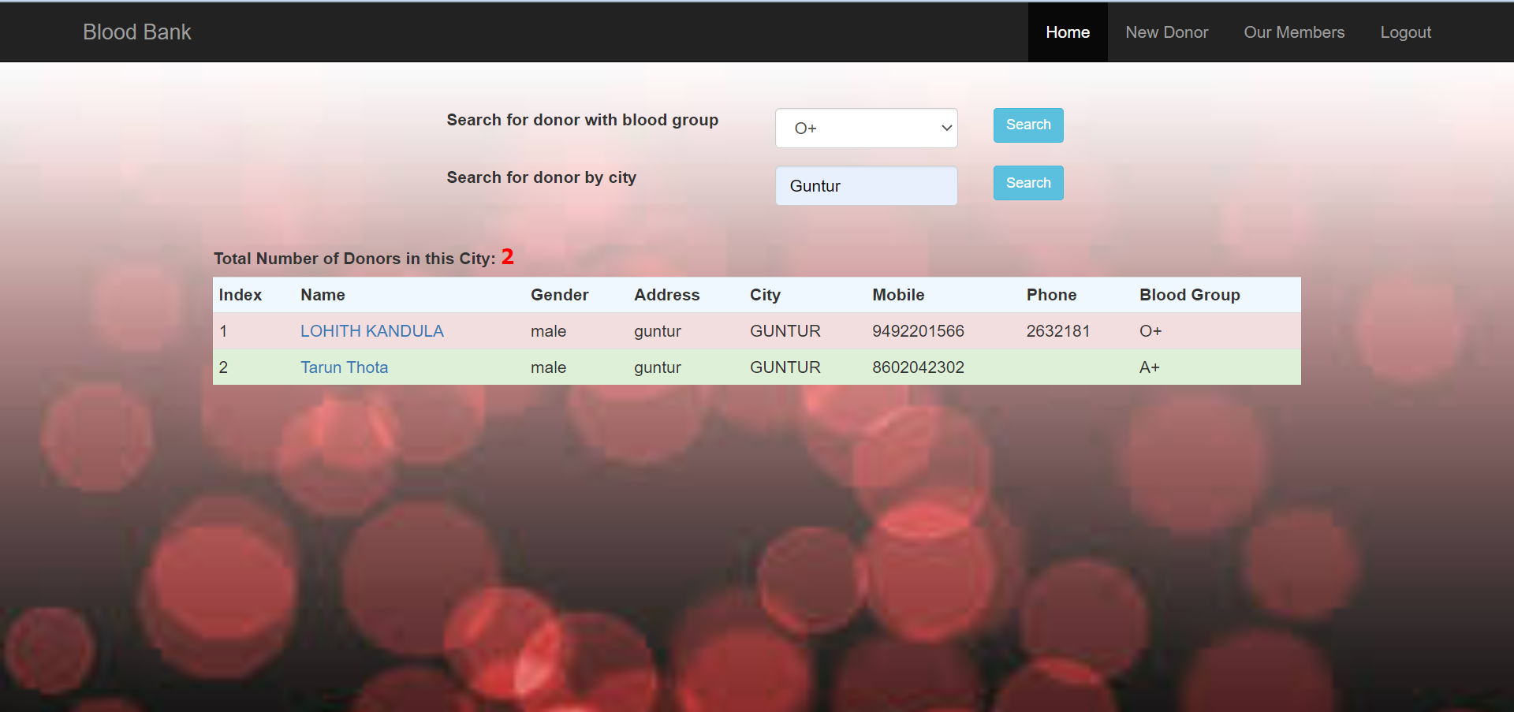

**Donor details after clicking on donor name:**

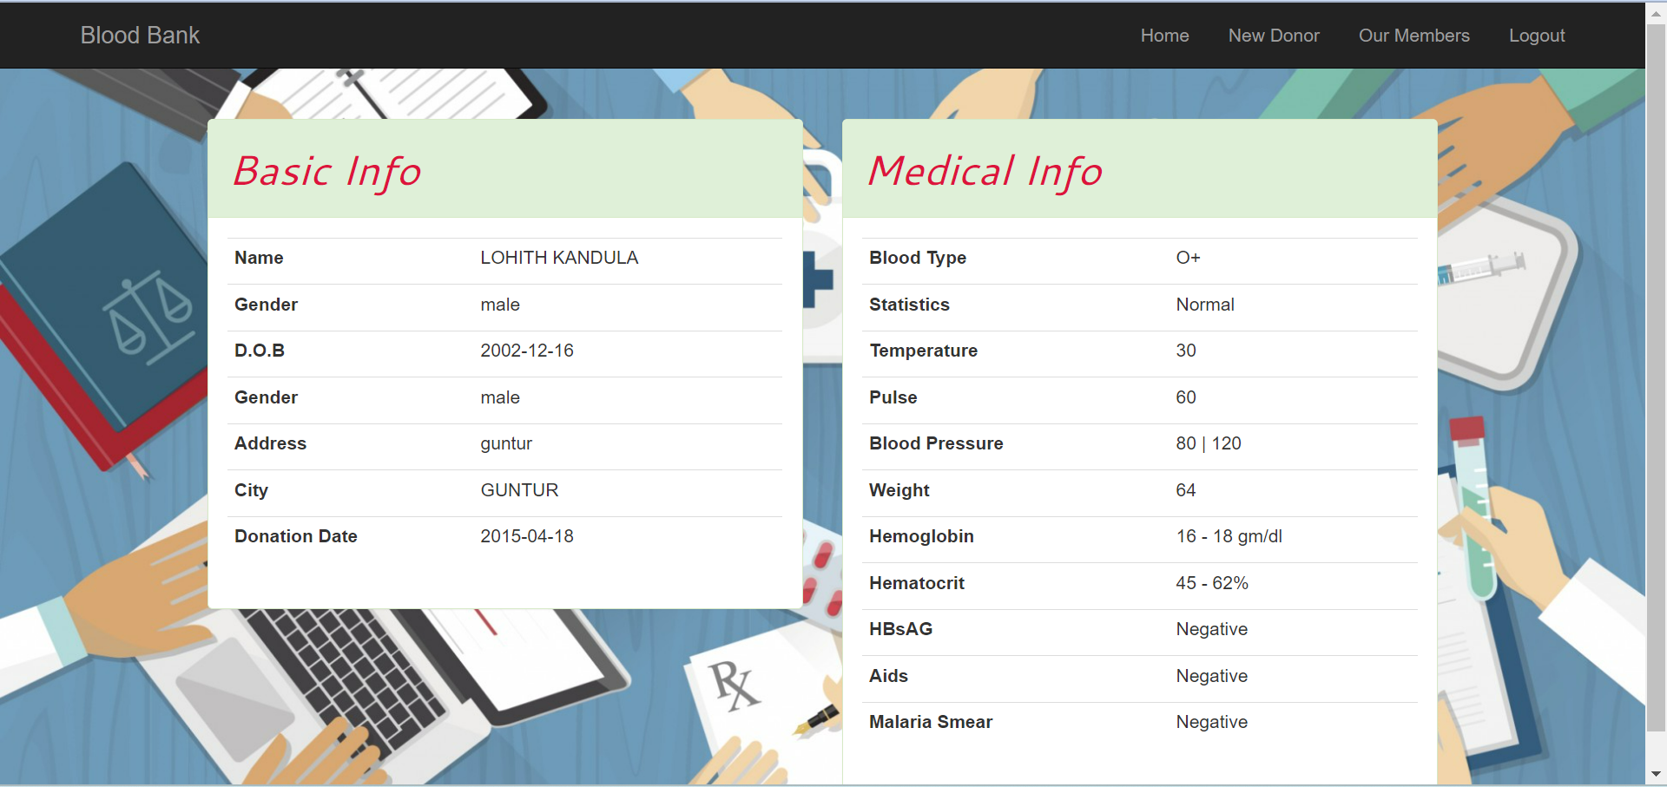

**New Donor:**

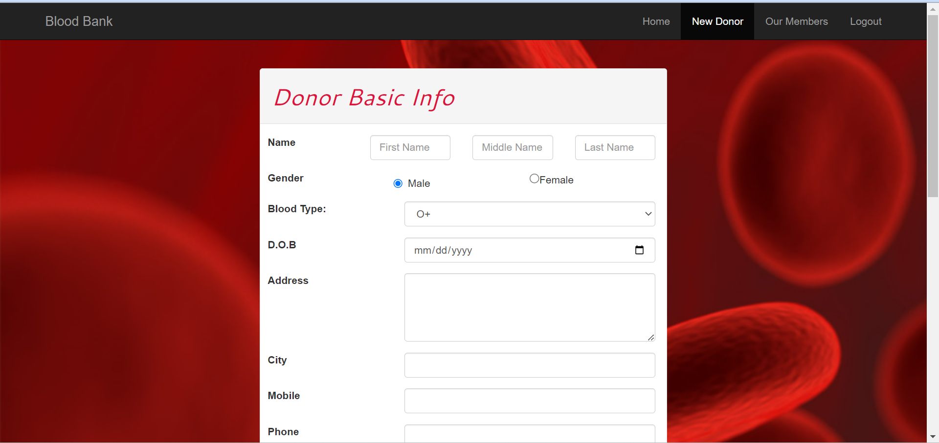

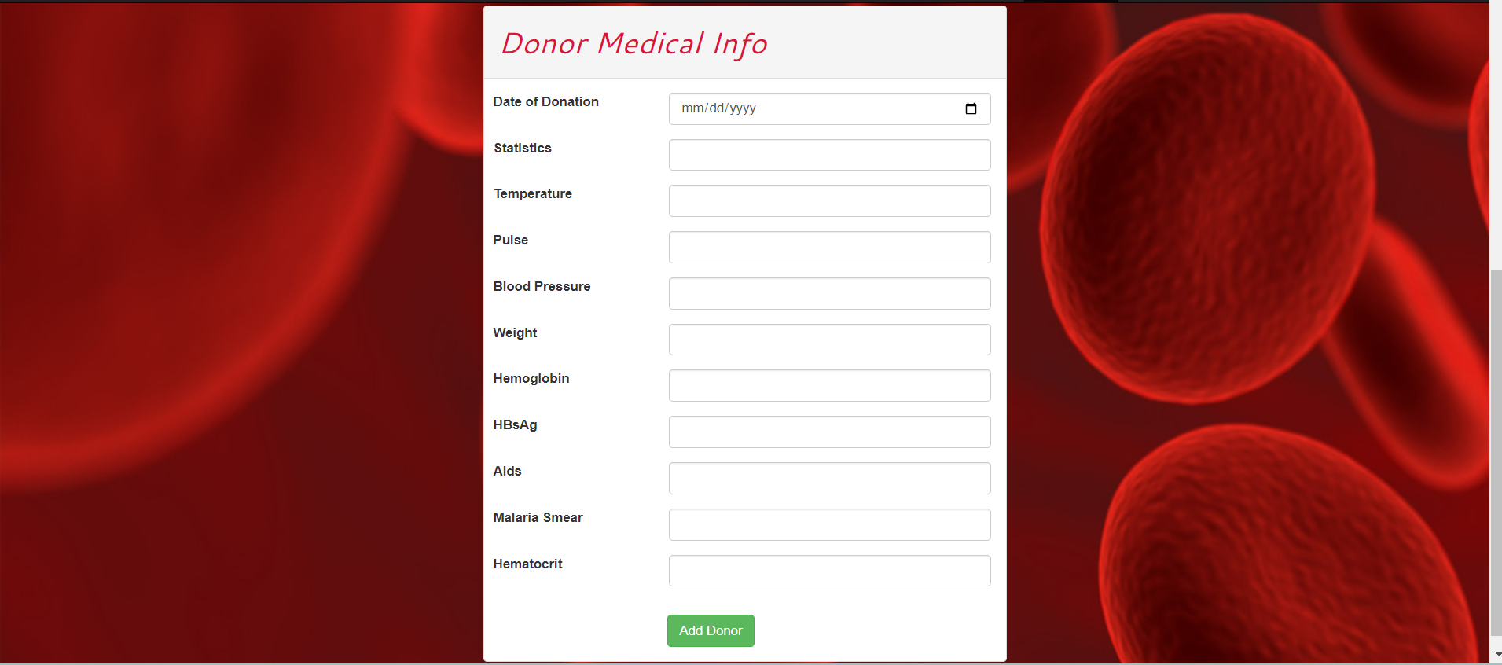

**Our Members:**

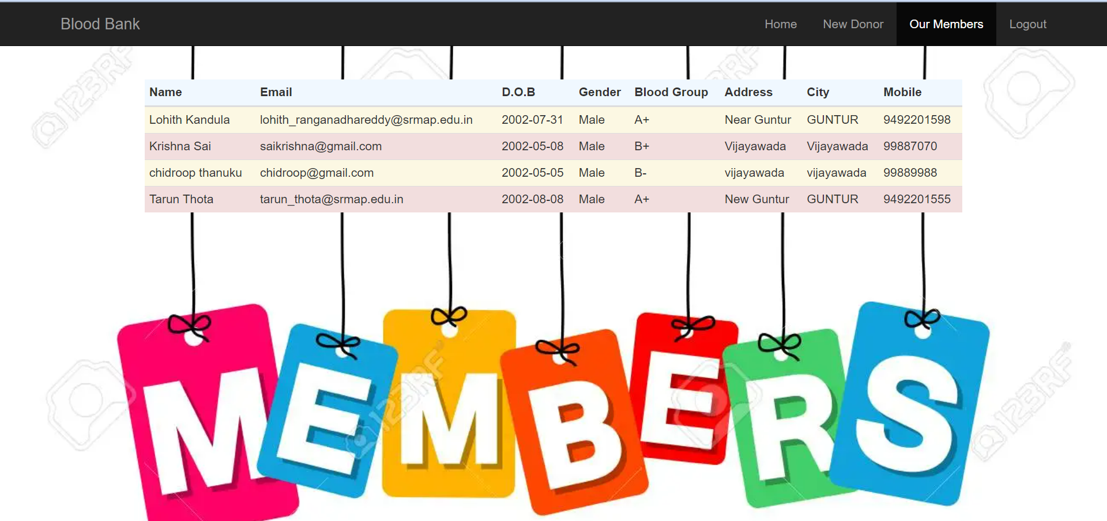

**After Logout:**



**Admin Login:**

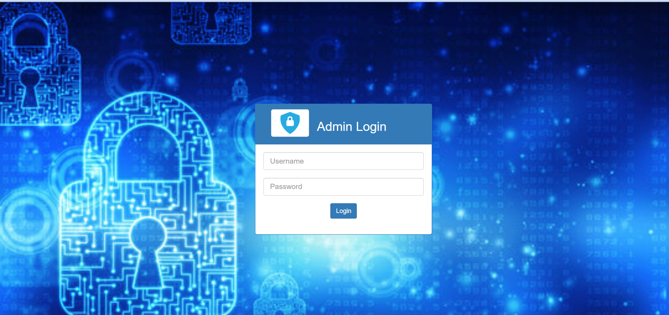

**Admin after login:**

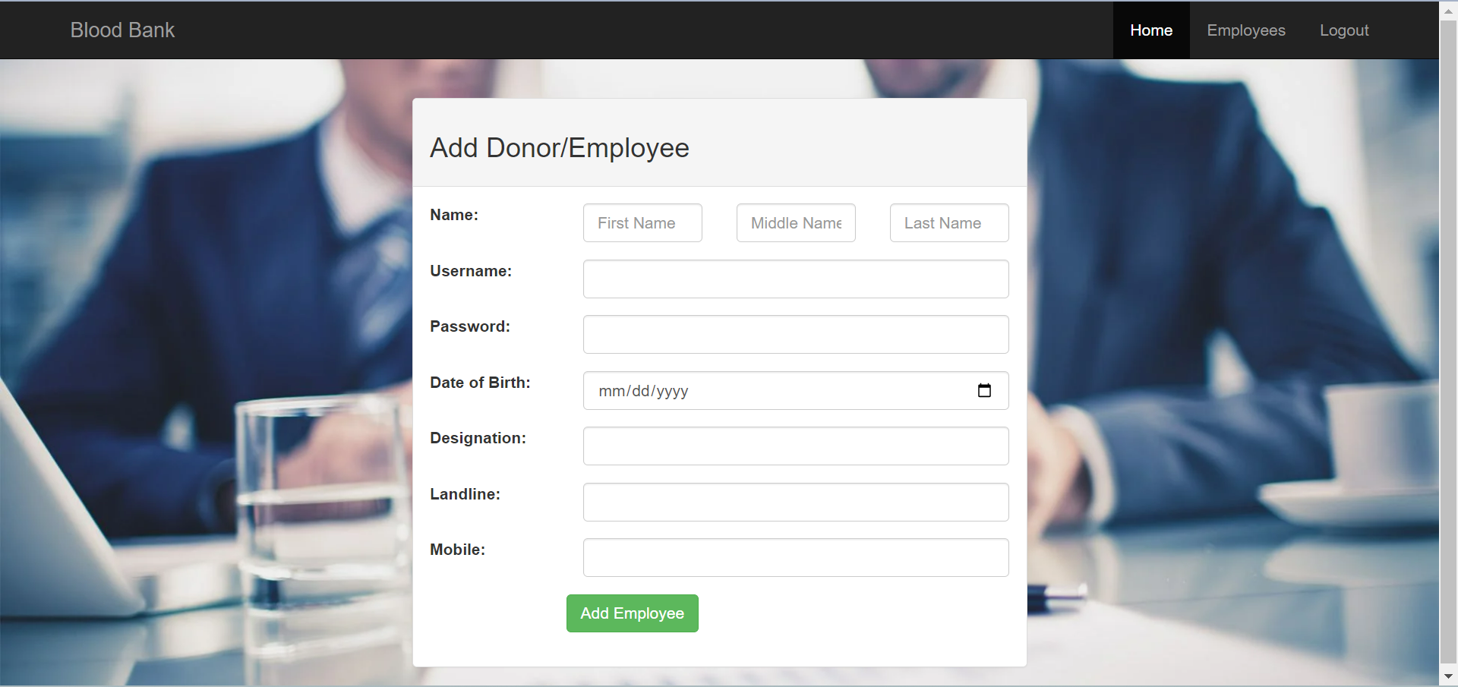

**Employees:**

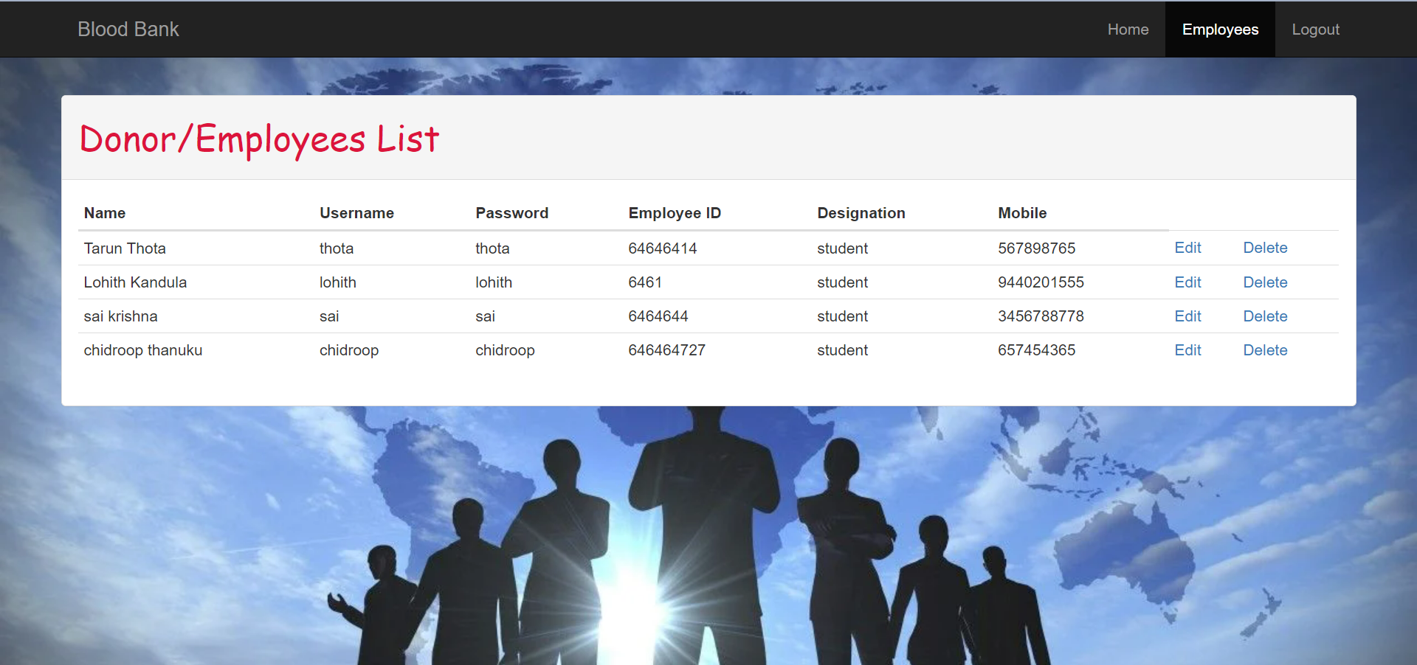

**Edit Employee details:**

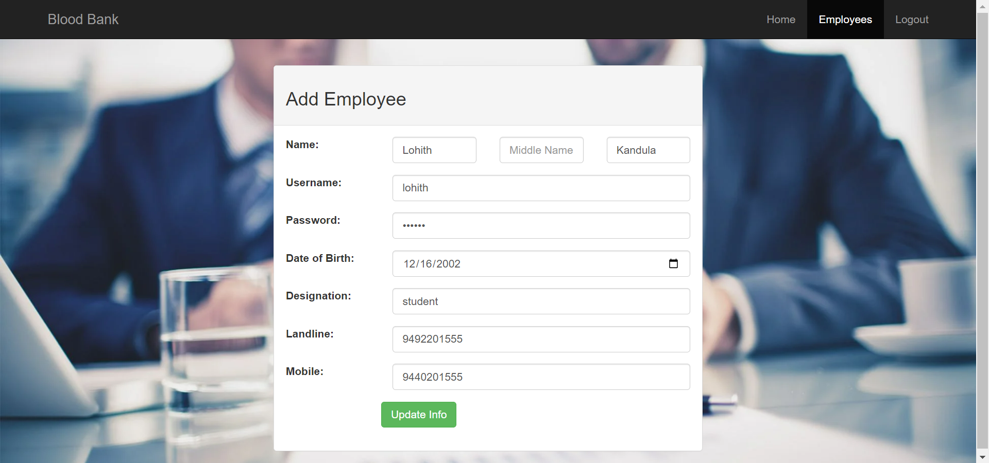

**Delete employee:**

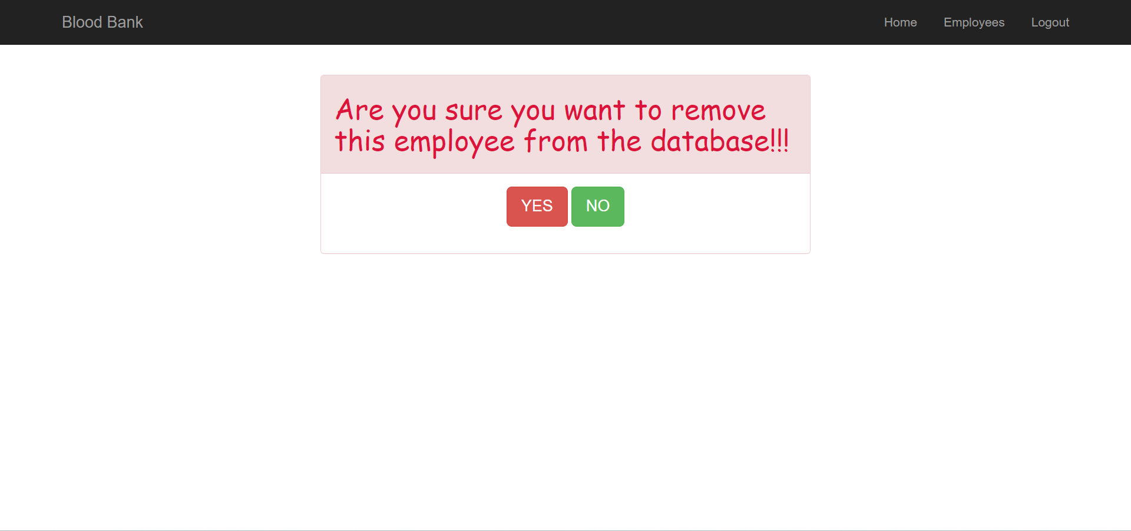

**After Logout:**



# 7. Conclusion

The development of a comprehensive and efficient blood bank system is crucial for enhancing the management of donor records, improving inventory control, and ensuring the safe and timely distribution of blood products. The existing manual systems have several disadvantages, including data duplication, limited accessibility, and the risk of data loss or misplacement.

Through the proposed scheme, a web-based platform is designed to address these limitations and provide a user-friendly interface accessible to authorized personnel from any location. The system incorporates modules for donor management, inventory control, blood request, and distribution, communication, and data security.

In conclusion, the implementation of the proposed blood bank system will contribute to the improvement of blood transfusion services, ensuring accurate donor records, efficient inventory management, and safe blood distribution. This project presents a significant step towards enhancing the effectiveness and reliability of blood bank operations, ultimately benefiting both donors and patients in need of life-saving blood transfusions.

# 

# 

# 

# 

# 

# 8. Future Work

In the future, we like to add the booking of bloodstock online by collaborating with various offline blood banks and hospitals. we like to extend our services throughout the state and late country. Integrating the blood bank system with existing health information systems, such as electronic health records (EHRs), can facilitate seamless data exchange and improve patient care coordination. This integration can enable healthcare providers to have access to relevant donor and blood product information directly within their clinical workflows.

Developing a mobile application for the blood bank system can offer increased accessibility and convenience for donors, healthcare professionals, and blood bank staff. A mobile app can allow donors to schedule appointments, receive notifications, and access their donation history, while healthcare professionals can request blood products and receive real-time updates on availability.

Use of artificial intelligence and predictive analytics to provide valuable insights into blood donation patterns, demand forecasting, and inventory management. By analyzing historical data and donor behavior, the system can optimize donation campaigns, predict blood shortage periods, and ensure efficient allocation of resources.

# References

* <https://www.idosi.org/mejsr/mejsr19(8)14/21.pdf>
* <https://ijariie.com/AdminUploadPdf/Blood_Bank_Management_System_ijariie6874.pdf>
* <https://www.sciencedirect.com/science/article/pii/S1877042815036940>
* <http://etd.aau.edu.et/handle/123456789/14414>
* <https://www.studocu.com/in/document/savitribai-phule-pune-university/msccomputer-science/blood-bank-system-managment/25462766>